Foot Wear
*Note - much of the following information has been blatantly plagiarized from REI.com
- Boots or Shoes
  - Considerations
    - Comfort – personal choice and experience
    - Weight – Rule of thumb “one pound of weight on your feet equals five pounds on your back” (energy expenditure) but plan accordingly for you pack weight and environmental conditions.
    - Stability & Protection - uneven or rocky trails
  - Types
    - Shoes
      - Trail Running Shoes
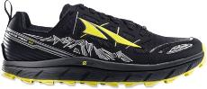
      - Hiking Shoes
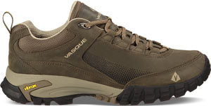

    - Boots
      - Hiking Boots
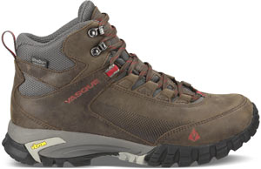
      - Backpacking boots
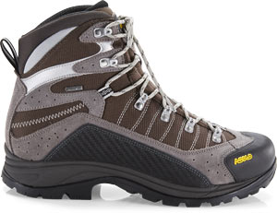
      - Mountaineering boots
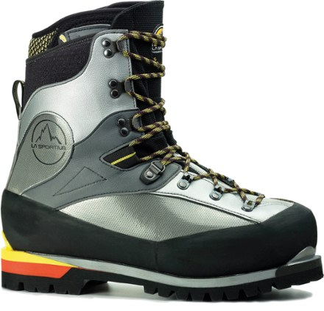

  - Materials and Features
    - Hiking Boot Uppers

Materials impact a boot’s weight, breathability, durability and water resistance.
      - Full-grain leather: Full-grain leather offers excellent durability and abrasion resistance and very good water resistance. It’s most commonly used in backpacking boots built for extended trips, heavy loads and rugged terrain. It is not as light or breathable as nylon/split-grain leather combinations. Ample break-in time is needed before starting an extended trip.
      - Split-grain leather: Split-grain leather is usually paired with nylon or nylon mesh to create a lightweight boot that offers excellent breathability. Split-grain leather "splits away" the rougher inner part of the cowhide from the smooth exterior. The benefit is lower cost, however, the downside is less resistance to water and abrasion (though many feature waterproof liners).
      - Nubuck leather: Nubuck leather is full-grain leather that has been buffed to resemble suede. It is very durable and resists water and abrasion. It’s also fairly flexible, yet it too requires ample time to break in before an extended hike. Synthetics: Polyester, nylon and so-called "synthetic leather" are all commonly found in modern boots. They are lighter than leather, break in more quickly, dry faster and usually cost less. Downside: They may show wear sooner due to more stitching on the outside of the boot.
      - Waterproof membranes: Boots and shoes billed as “waterproof” feature uppers constructed with waterproof/breathable membranes (such as Gore-Tex® or eVent®) to keep feet dry in wet conditions. Downside: The reduced breathability created by a membrane (compared to the ventilating mesh used on some nonwaterproof shoes) may encourage feet to sweat on summer days.
      - Vegan: Vegan-friendly hiking boots and shoes are made without any animal ingredients or byproducts.
      - Insulation: Synthetic insulation is added to some mountaineering boots for warmth when hiking on snow and glaciers.

    - Hiking Boot Midsoles -
The midsole, which provides cushioning, buffers feet from shock and largely determines a boot’s stiffness. Stiff boots might not sound like a good thing, but for long hikes on rocky, uneven terrain they can mean greater comfort and stability. A stiff boot won’t allow your foot to wear out by wrapping around every rock or tree root you step on. The most common midsole materials are EVA (ethylene vinyl acetate) and polyurethane.
      - EVA is a bit cushier, lighter and less expensive. Midsoles use varying densities of EVA to provide firmer support where needed (e.g., around the forefoot).
      - Polyurethane is generally firmer and more durable, so it’s usually found in extended backpacking and mountaineering boots.
    - Hiking Boot Internal Support
      - Shanks: These 3–5mm thick inserts are sandwiched between a boot’s midsole and outsole to add load-bearing stiffness to the midsole. They vary in length; some cover the entire length of the midsole, while others only cover half.
      - Plates: These thin, semiflexible inserts are positioned between the midsole and the outsole, and below the shank (if included). They protect feet from getting bruised by roots or uneven rocks.
    - Hiking Boot Outsoles
Rubber is used on all hiking boot outsoles. Additives such as carbon are sometimes added to backpacking or mountaineering boots to boost hardness. Hard outsoles increase durability but can feel slick if go you off trail.
      - Lug pattern: Lugs are traction-giving bumps on the outsole. Deeper, thicker lugs are used on backpacking and mountaineering boots to improve grip. Widely spaced lugs offer good traction and shed mud more easily.
      - Heel brake: This refers to the clearly defined heel zone that is distinct from the forefoot and arch. It reduces your chance of sliding during steep descents.
    - Crampon Compatibility
If you plan to do mountaineering or winter backpacking, having compatible boots and crampons is essential for your safety.

  - Hiking Boot Fit
    - Hiking boots should fit snug everywhere, tight nowhere and offer room to wiggle your toes. Try them on at the end of the day (after feet swell) and with the socks you plan to wear.
    - Know your size. It’s best to have your foot's length, width and arch length measured on a specially calibrated fit device at REI. Foot volume, another key to good fit, must be assessed by a specialist at a store.
    - You can also measure your foot length and use REI.com sizing charts to find your size. Double-check length later by pulling the insoles out of the boots and standing on them; you should have a thumb’s width of space between your longest toe and the end of the insole.
    - Try on boots at the end of the day. Your feet normally swell a bit during the day’s activities and will be at their largest then. This helps you avoid buying boots that are too small.
    - If you wear orthotics, bring them along. They impact the fit of a boot.
    - Wear appropriate socks. Familiar socks help you more quickly assess the fit and feel of new footwear. Make sure the thickness of the socks matches what you intend to wear. And on the trail, go with synthetic rather than slow-drying cotton socks, which are more likely to give you blisters.
    - Spend some time in the boots. Take a stroll through the store. Walk up and down stairs. Find an inclined surface and walk on it.
    - Fit issues to share with your footwear specialist: You don't want to feel odd bumps or seams, or pinching in the forefoot, nor toes hitting the end of the boot when it's on an incline. If the boots are laced firmly and you still feel space above the top of your foot, then the volume of the boot is wrong.
    - When shopping online, consider a brand you’ve worn before. Most boot companies tend to use a consistent foot model over time, so the fit is likely to be similar.
    - Consider aftermarket insoles (a.k.a. footbeds). Insoles come in models that can enhance comfort, support or fit—or all three.
    - Break your boots in before your first trip. Too many sore-footed hikers overlook this important step.
  - Breaking in Your Hiking Boots
    - Even great-fitting boots need to get in sync with your feet. If you take the time to break in a new pair of hiking boots, you’ll enjoy many comfortable miles on the trail together.
    - Different boots take different break-in times. Light hikers may feel perfect right out of the box, while burly leather models may require weeks. The leather needs time to soften up so your boots and feet can conform to one another.
    - The break-in process won’t turn a poor fit into a good one.
    - Go Slow and Steady
      - Wear your boots inside the house. Wear the socks and insoles you’ll be wearing on the trail and tie your boots snugly, but not too tight. Make sure your tongues and gussets are straight. Your new boots will be a little stiff at first, which is fine.
      - Walk around the block and around town. Make sure your boots feel good at each stage before upping the distance.
      - Put on a daypack and hit the trail. Off pavement is where serious breaking in happens. Be sure you gradually increase both weight and mileage throughout this phase.

- Sox
  - Basic sock categories:
    - Lightweight hiking/backpacking socks: Best for warm conditions and easy trails, these stress moisture wicking and comfort over warmth. They are relatively thin, yet are warmer and provide more cushioning than liners alone. They can be worn with or without liner socks.
    - Midweight hiking/backpacking socks: These provide cushioning and insulation in moderate to cold conditions. Many models have extra padding built into high-impact areas like the heel and the ball of the foot. These socks should be worn with liners.
    - Mountaineering socks: Mountaineering socks are the thickest, warmest and most cushioned socks available. They are designed for long trips, tough terrain and cold temperatures. Usually, mountaineering socks are too thick and warm for basic backpacking journeys in warm conditions.
    - Liners: Sock liners are thin, lightweight wicking socks designed to be worn right next to your skin. These liners wick sweat away from the surface of your foot to keep you dry and more comfortable. Liners also limit the amount of abrasion between your outer sock and your skin. They are designed to be worn under other socks.
  - Material Options
    - Wool: Wool is the most popular natural sock material. It is warm, cushioning and retains warmth when wet. While older ragg wools could be scratchy next to your skin, newer merino wools are itch-free. Most wool socks use blends of wool and synthetic materials for better durability and faster drying.
    - Synthetic insulating materials: Some man-made materials are designed to insulate like wool and wick moisture. These materials (Hollofil®, Thermax®, Thermastat®) trap warmth like wool, but dry more quickly and are more abrasion resistant.
    - Silk: A natural insulator, silk is comfortable and lightweight, but not as durable as other options. It's occasionally used in sock liners for reliable moisture wicking.
    - Synthetics wicking materials: Synthetic wicking materials (like polypropylene and CoolMax®) used in wicking sock liners are often woven into thicker backpacking socks as well, to enhance moisture-wicking performance.
    - Cotton: 100% cotton is not recommended as a sock material for hiking. Cotton absorbs sweat, dries slowly, provides no insulation when wet and it can lead to blisters out on the trail. However, cotton is quite comfortable and, when combined with wool or other wicking and insulating fibers, can be a good choice for light hiking in summer.
    - Cushioning materials: Many hiking socks provide extra cushioning around the heel, the ball of the foot and the toe area to increase comfort. The padding is created either by increasing the density of the weave or, in some cases, by weaving long-wearing materials like acrylic into those areas. This extra padding can be a real foot-saver on rough terrain.
    - Support materials: Many of today's hiking socks include a small percentage of either stretch nylon or spandex. These elastic materials help socks hold their shape and keep bunching and wrinkling to a minimum.

